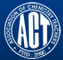 Association of Chemistry Teachers (ACT)
C/o. Homi Bhabha Center for Science Education (HBCSE), TIFR, Mumbai-400 088

News Letter Issue 1/ April, 2015 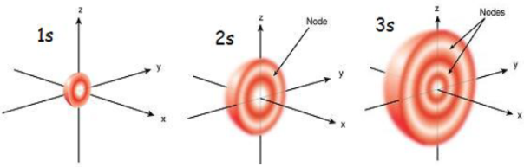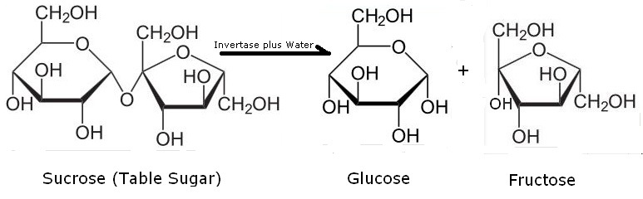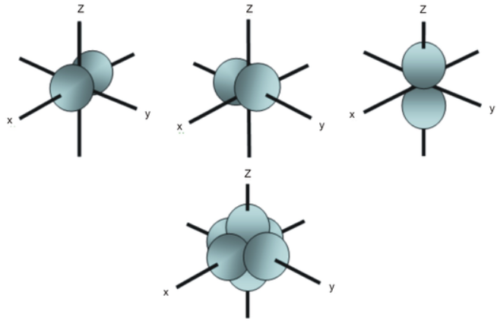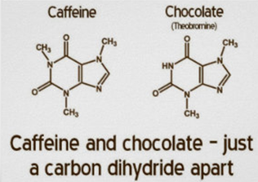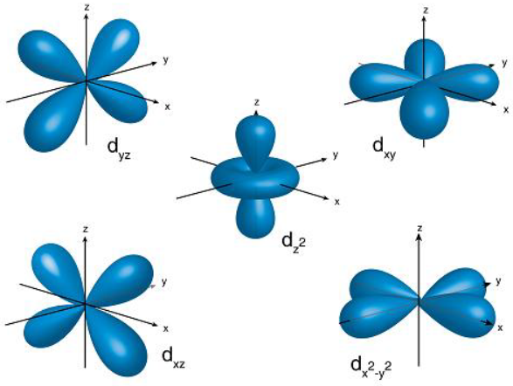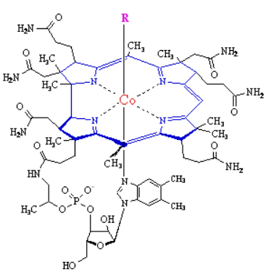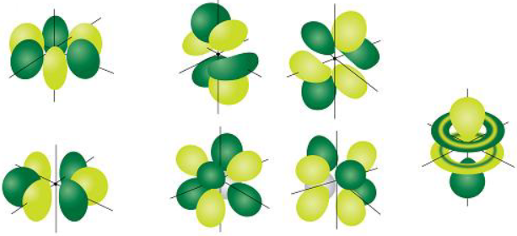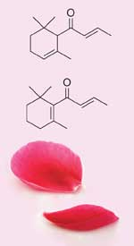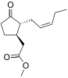

From the Editor’s Desk:
The present issue covers the period: January – April, 2015. The focus in this issue is to bring out the spectrum of activities across all the zones of ACT; achievements, awards & rewards of individual members and those across the globe; latest innovations; and bring out current research trends, for the benefit of ACT – Members. We also keep the Members informed of the forthcoming events. The Editorial Board invites contributions from Members in the form of interesting articles for the forthcoming issues of ACT – News Letter. If encouraged by the Members, we intend to publish research articles by Members after a peer review by an expert committee duly appointed.
--------------------------------------------------------------------------------------------------------------------------------
Achievements, Awards & Rewards - 2015
An Indian-origin scientist at the Massachusetts Institute of Technology, who has developed artificial human micro livers for drug testing, has won a prestigious $2, 50, 000 Heinz award for her work in tissue engineering and disease detection. She is also using micro livers in the lab to model malaria infection and test drugs that can eradicate malaria parasites completely. She hopes to eventually develop implantable liver tissue as a complement or substitute for whole-organ transplant.
The Hindu, Dated 27-04-2015
---------------------------------------------------------------------------------------------------------------------------------
Susanta Lahiri, a co-creator of element – 117, awarded Hevesy Medal
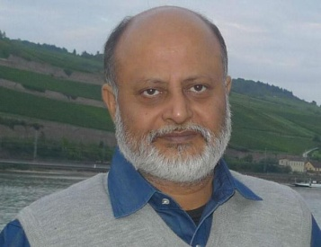The Hindu, Dated April 16, 2015
Professor Susanta Lahiri, Chemical Sciences Division, Saha Institute of Nuclear Physics, Kolkata, received the Hevesy Medal Award 2015, on April 12 at the Tenth International Conference on Methods and Applications of Radio-analytical Chemistry for his outstanding contributions to heavy ion induced radioisotope production, tracer packet technique, converter targets, and green chemistry.
---------------------------------------------------------------------------------------------------------------------------------
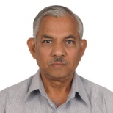Dr. M. R. R. Prasad, EC – Member of ACT has been nominated and cleared by the special committee for inclusion of his biography in Who’s Who in the world, a global reference source relied upon by universities, libraries, corporations, and governments around the world.
--------------------------------------------------------------------------------------------------------------------------------
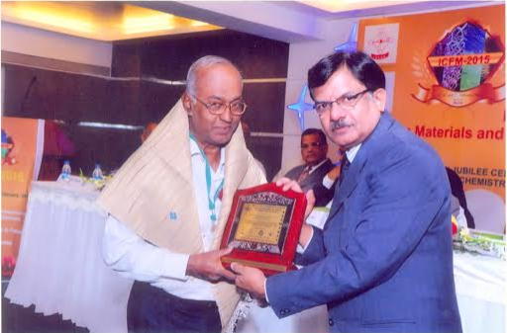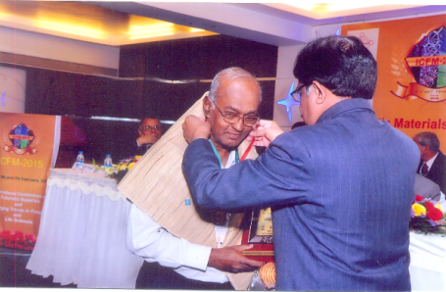
Emeritus Professor M. Swaminathan receiving life time achievement for material science during the International Conference on Futuristic Materials and Emerging Trends in Forensic and Life Sciences, held during February5th -7th, 2015 at R. T. M. Nagpur University, Nagpur.

Prof. (Dr.) Gajanan G. Chaudhuri, Head, Department of Chemistry, Shivaji Science College, Amravati and Life Member of ACT, received Best Teacher Award from Sant Gadge Baba Amravati University, Amravati, Maharashtra.
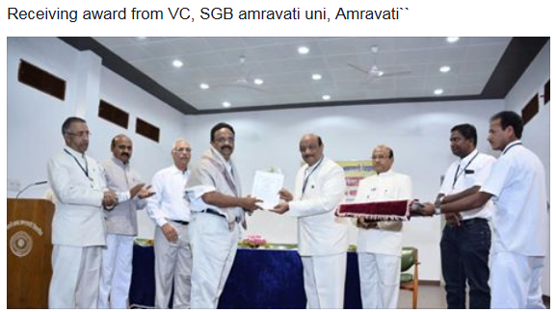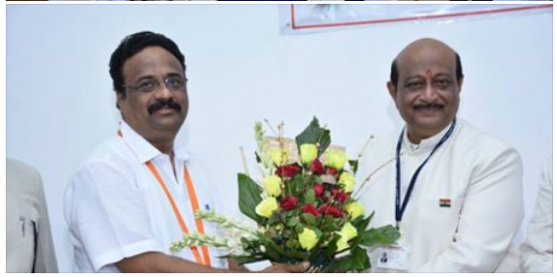
-----------------------------------------------------------------------------------------------------
Activities of ACT during January – April, 2015

- Prof. S. B. Jonnalagadda of University of KwaZulu Natal, Durban (South Africa)
conducted workshop on "Computers in Chemistry” on 19th December 2015 at Madhav Science PG College, UJJAIN supported by ACT.

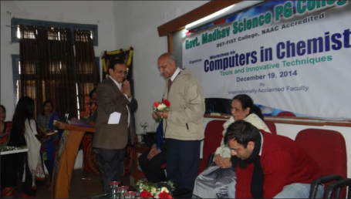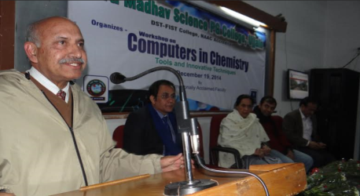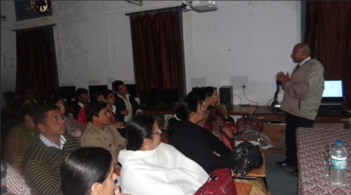

- Arts, Science and Commerce College, Rahata, Tal – Rahata, Dist. – Ahmednagar, Organized a 2 days Seminar on “Recent Trends of Research in Chemistry”, during February 13 – 14, 2015
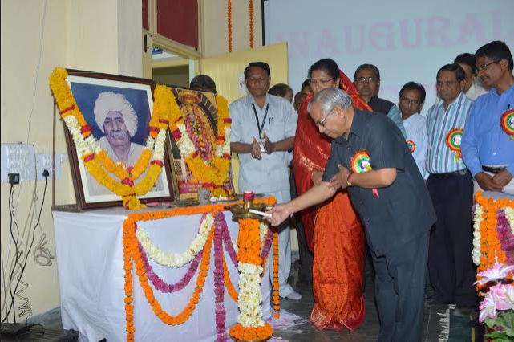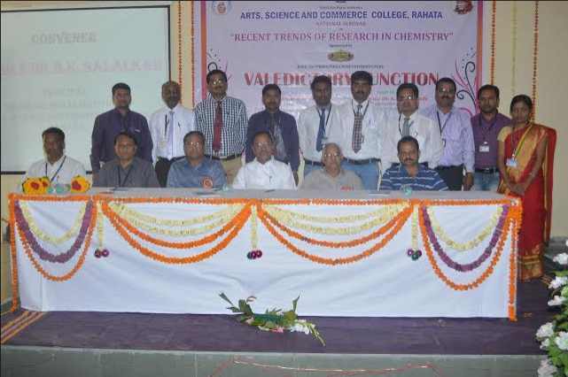

- National Science Day Celebrations were held at Chegu Vidyalayam, Jaggayyapeta, Andhra Pradesh on February 28th, 2015.
- Dr L. Devaraj Stephen organized 2nd National Seminar on Concepts of Chemistry on March 28 2015 in Valliammai Engineering College.
- On April 01, 2015 University of Kashmir conferred Doctorate of Science to Prof. C. N. R. Rao, National Science Researcher & Linus Pauling Researcher, in a specially organized Convocation in his honor. On this occasion a popular lecture titled “Doing Science in India” by Prof. C. N. R. Rao was organized at the Department of Chemistry of University of Kashmir.
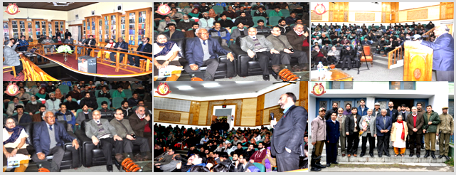

- National Science Day celebrations were held at Nagam Sai Residential Concept School, Yanam, Puducherry

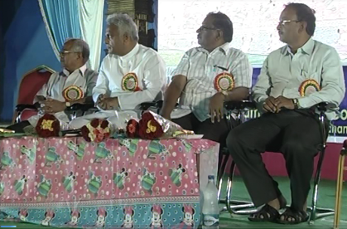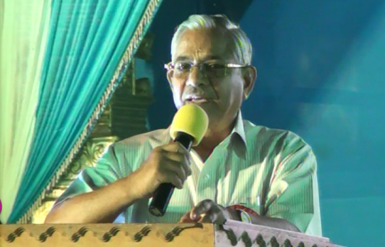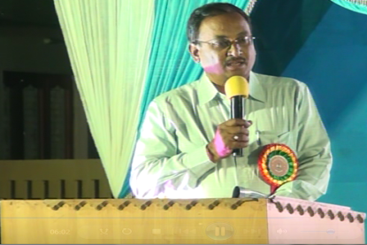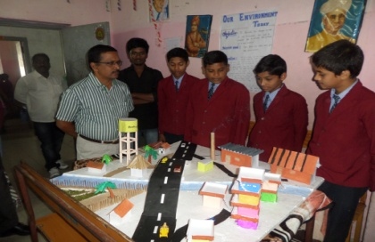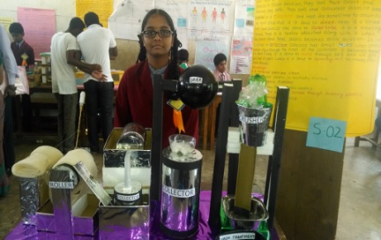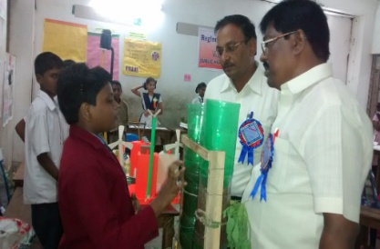

- Department of Chemistry, A N College, Patna have celebrated the Nation Science Day on February 28, 2015 under the banner of ACT. Students of neighboring +2 schools, along with students from Physics, Chemistry, Botany, Zoology, and Mathematics Honors of the college participated in the celebrations. Dr. Rakesh Kumar, Chief Scientist & Director, NEERI, Zonal Office, Mumbai was the Chief Guest on this occasion. Former Heads of Science Department – Dr. R. N. Thakur, Dr. D. Prasad, Dr. B. Singh gave motivational talks on this occasion. Science quiz competitions, extempore competitions, presentation of models, highlights of Nobel Laureates in science of the last 15 years and their achievements were presented. 193 students have participated in this program. The special attraction of this event was presentation of the periodic table in an innovative way by Mr. Ankit Kumar of B. Sc. Chemistry (Hons.)-Part-I. Principal of the college distributed the prizes to the winning students.

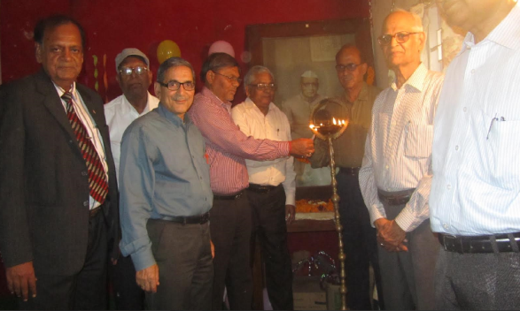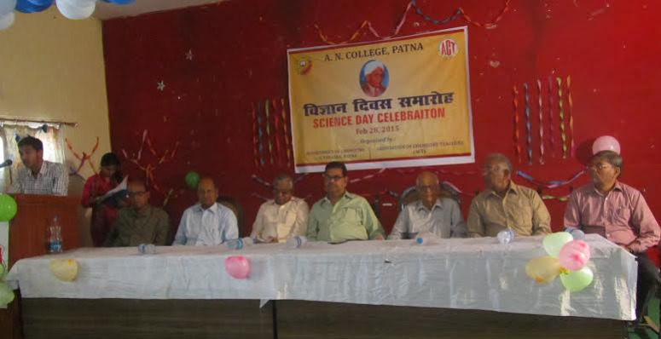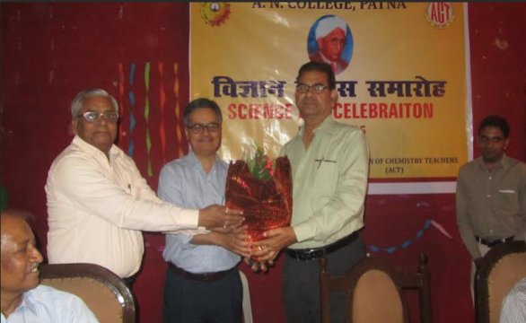
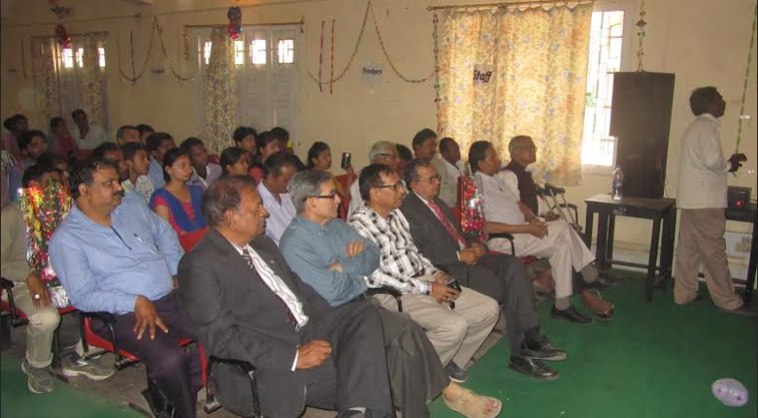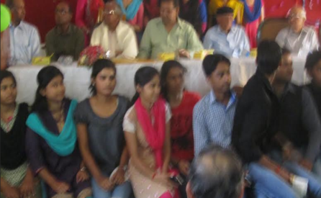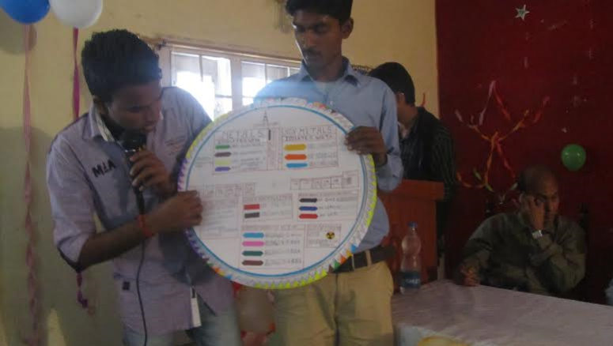

- National Science Day Celebrations were held at Gayatri Vidya Parishad, Visakhapatnam, Andhra Pradesh on February 28th, 2015. Approximately 700 students participated in the preliminary selections from selected 10 Schools of which 9 were municipal schools; and 5 colleges. Finals were conducted at GAYATRI Vidya Parishad UG & PG College. Science Exhibition was also organized at this college from 9-00 am to 4-00 pm, and prizes were distributed.

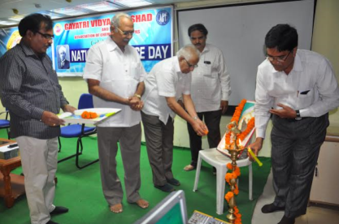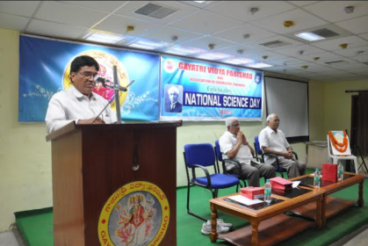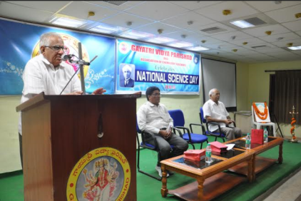
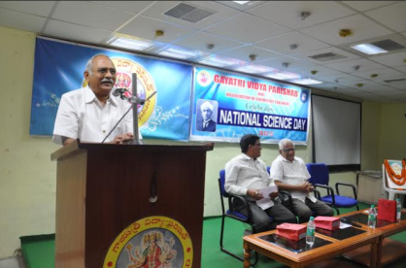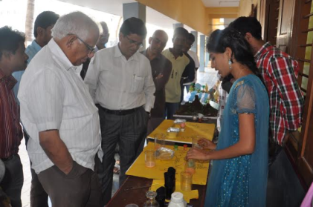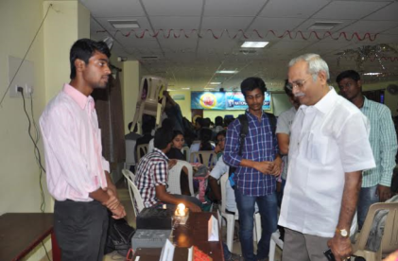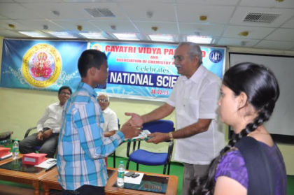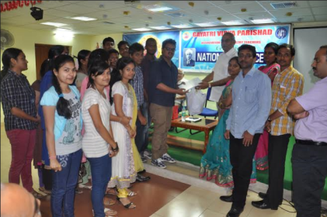

- Department of Chemistry, SRM University, Ramapuram campus in association with the Association of Chemistry Teachers (ACT) celebrated National Science Day on February 28th, 2015. The program was inaugurated by the Chief Guest Dr. N. Vasudevan, Director, Center for Environmental Studies, Anna University, Chennai. Dr. N. Sethuraman, the Registrar of SRM University presided over the inaugural function. Dr. V. Subbaiah Bharathi, Dean, SRM University Ramapuram Campus; and L. Antony Michael Raj, Vice-Principal (Academic), felicitated the gathering. Prf. M. Swaminathan, Vice-President, ACT-Southern Zone gave the vote of thanks. As a part of these celebrations – speech competitions, quiz competitions, drawing competitions, on topics such as - “Role of Science in Nation Building”; “Global Warming Issues; “Challenges and Harnessing Renewable Energy – Need of the Hour” were held. Also, innovative science projects display contest was held. Further, Oral and Poster presentations were organized for engineering students on a topic entitled “Nanoscience – Boon for Technological Development and Missile Technology”. Demonstrations on scientific experiments were held by Prof. T. S. Natarajan of IIT, Madras. Winners of various competitions were given medals and certificates in the valedictory function.

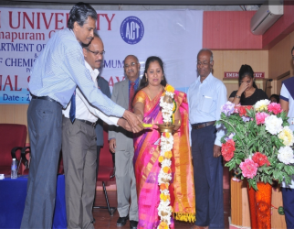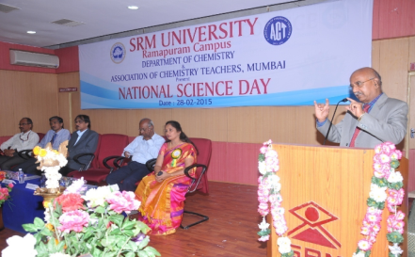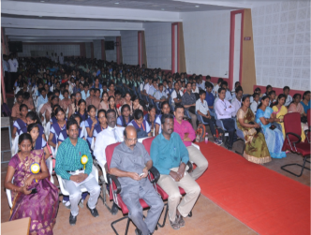
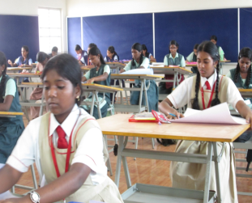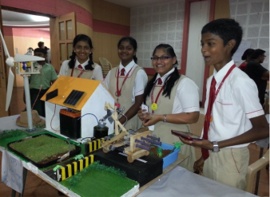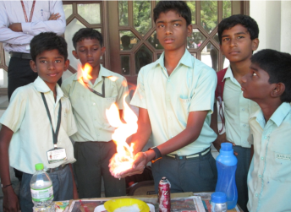
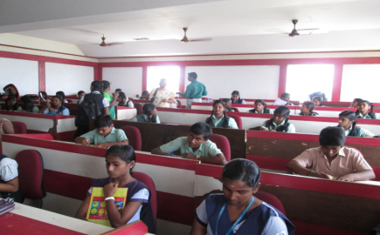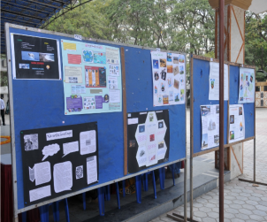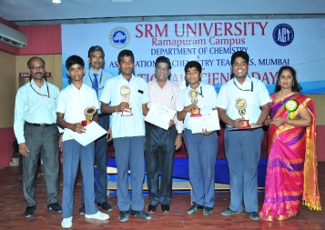
--------------------------------------------------------------------------------------------------------------
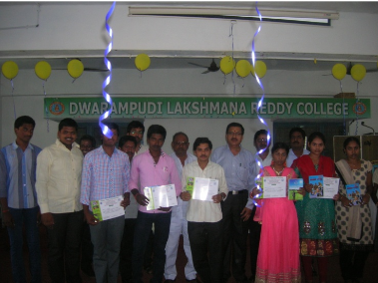D. L. R. College, G. Mamidada, a rural college celebrated Science Day celebrations n 8-02-2015.
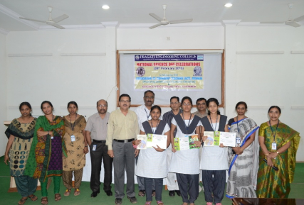Pragati Engineering College, Surarampalem, Kakinada celebrated Science Day celebrations n 8-02-2015.
- Sri Chaitanya V. S. Lakshmi Mahila Kalasala (Women’s College) celebrated Science
Day celebrations on 8-02-2015.
---------------------------------------------------------------------------------------------------------------------
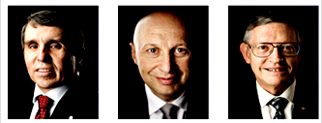The Nobel Prize in Chemistry 2014 was awarded jointly to Eric Betzig, Stefan W. Hell and William E. Moerner "for the development of super-resolved fluorescence microscopy".
-------------------------------------------------------------------------------------------------------------------------------------
Small quantities of silver can serve as an efficient catalyst to convert aldehydes to acids
Instead of the classical methods using stoichiometric amounts of expensive or toxic metal oxidants, a tiny bit of silver, combined with water and air, can convert aldehydes into acids efficiently—according to a new study by McGill University researchers.

The findings, published March 27 in the journal Science Advances, could lead to a variety of possible applications in the chemical industry. The results also promise to advance the search for more environmentally friendly chemical conversion reactions using air as a green oxidant, said Chao-Jun Li, senior author of the paper and Canada Research Chair in Green Chemistry at McGill.
Source: Mingxin Liu et al, Science Advances, 27 March 2015
DOI:10.1126/sciadv.1500020
-------------------------------------------------------------------------------------------------------------------------------------
A Love Hate Relationship with Chlorine
Christina Reed
Ref. EARTH, Jan 6, 2011
Chlorine is the anti-hero of disinfected drinking water. A pathogen-killer with that fresh swimming pool scent, the green gas has kicked cholera and e. coli to the curb in most developed nations. In recent years however, chlorine’s “dark side” – a tendency to increase the rate of bladder cancer and miscarriages – has prompted water treatment facilities to shun the chemical and turn to alternative disinfectants.
---------------------------------------------------------------------------------------------------------------
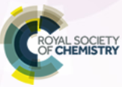
Creating flipped videos
Rob Campbell, Head of chemistry at Nowerhill High School, UK

Over recent years, a lot of emphasis has been placed on flipped teaching as a way to improve student performance. Using this approach, the teacher provides guidance and support for students in advance of the lesson. Flipped teaching may be as simple as asking students to read a chapter of a textbook before a lesson, but increasingly pre-lecture videos are being used to free up face-to-face time. Simon Lancaster and David Read covered the use of flipped teaching in university lectures for Education in Chemistry in September 2013.

These are my experiences of using Zaption as a host site for flipped tutorials.

Why do I flip?
Some time ago, while teaching a Year 13 class, I realized my students were adding chemicals together and diligently recording results without any understanding of the underlying chemistry of what was occurring. They could tell me what a qualitative test for an alcohol was, but there was no deeper understanding about why that test worked.

I decided I wanted to give my students something more, so I made my first YouTube video on enthalpy of solution and asked the students to bring in questions they wanted to investigate.

Having watched the video, the students already had an understanding of basic definitions when they arrived. This meant that more classroom time could be spent investigating different applications. Students planned their own investigations and were actually learning rather than following a ‘recipe’.

Since then, I have continued to make flipped videos on a regular basis, which I believe allows my students to investigate the topics at their own pace and to a suitable depth of understanding.

How do I flip my lessons?
I make my flipped videos using three tools:
- Doceri – this is an app that turns your iPad into a whiteboard that records what you write and say.
- Camtasia – I use this to record what is happening on my desktop computer when I want to show web-based animations of flash files. The app lets you edit the animations and turn them into mp4 video files.
- Digital camera – most often, I use the digital camera on my Smartphone to record what I write on a physical whiteboard.

I then upload the video to YouTube and create a tutorial on Zaption.
How does it work?
Zaption is a web app that lets teachers create video tutorials to use as teaching tools. On Zaption, I can upload photos, quizzes, questions or videos (private or from YouTube) to create a learning ‘tour’.

What Zaption calls tours are essentially tutorials, to which the user can upload questions for their students to answer. I can give model answers to questions, which, unlike in a classroom context, students can watch over again to ensure understanding. The great power of Zaption, however, is that the assessment results it generates can be used to structure the face-to-face interactions.

How do I see student responses?
Zaption provides an analytics section on the app. This gives me feedback on which students have watched the video, how long they have watched the video for and most importantly what the student responses to the questions were – all in advance of the lesson.

This allows me to effectively differentiate and plan face-to-face time to allow students to improve and develop their own understanding. Also, using Zaption, I can scaffold questions and use analytics to group students to work most effectively in the face-to-face lesson.

What do the students think?
At the end of each tour, I ask students whether the video was helpful and how it compared with a traditional classroom learning experience. Although not completely unanimous, many students give positive feedback saying, for example, that the computer models helped with their 3D visualization much more than molecular modeling kits would. Students also say that it helps to be able to revisit tutorials as many times as they like.
Trends in liquid chromatography coupled to high-resolution mass spectrometry for multi-residue analysis of organic micro pollutants in aquatic environments
Vergeynst Leendert, Herman Van Langenhove, Kristof Demeestere
TrAC Trends in Analytical Chemistry, Vol. 67, April 2015, Pages 192 – 208

The spectrum of identified organic trace compounds in the aquatic environment is most probably only “the tip of the iceberg”. Modern liquid chromatography coupled to time-of-flight and Orbitrap high-resolution mass spectrometry (HRMS) promise to extend knowledge on the environmental occurrence and fate of (un)known micro pollutants. Thanks to its unique ability to measure analytes based on accurate mass, full-spectrum HRMS can simultaneously gain qualitative and quantitative information of a virtually unlimited number of analytes.

This critical review covers recent trends and advances in this field, as reported over the period 2003–14. We focus on five key topics: multi-residue aspects of HRMS-based analysis, accurate mass measurement, suspect and non-target screening, selective quantification, and the combined use of quantitative and qualitative HRMS. The acquired insights provide stepping stones to improve understanding of the specific nature of state-of-the-art HRMS, and the challenges and the prospects for future research.

Palladium (0) NHC complexes: a new avenue to highly efficient phosphorescence
Adam F. Henwood,ª Mathieu Lesieur,^{b} Ashu K. Bansal,^{c} Vincent Lemaur,^{d} David Beljonne,^{d} David G. Thompson,^{e} Duncan Graham,^{e} Alexandra M. Z. Slawin,^{b} Ifor D. W. Samuel,*^{c} Catherine S. J. Cazin*^{b} and Eli Zysman-Colman*ª

Chem. Sci., 2015, Advance Article / DOI: 10.1039/C4SC03914A Received 17 Dec 2014, Accepted 02 Apr 2015 / first published online 02 Apr 2015

We report the first examples of highly luminescent di-coordinated Pd(0) complexes. Five complexes of the form [Pd (L)(L′)] were synthesized, where L = IPr, SIPr or IPr* NHC ligands and L′ = PCy₃, or IPr and SIPr NHC ligands. The photophysical properties of these complexes were determined in degassed toluene solution and in the solid state and contrasted to the poorly luminescent reference complex [Pd(IPr)(PPh₃)]. Organic light-emitting diodes were successfully fabricated but attained external quantum efficiencies of between 0.3 and 0.7%.

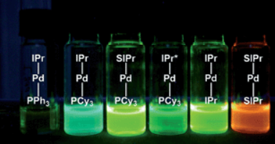
----------------------------------------------------------------------------------------------------------------------
Turning cobwebs into heart tissue
Source: International Innovation/ Disseminating Science, Research, and Technology
April 14, 2015

A protein found in spiders’ webs may prove to be an ideal scaffold for growing heart tissue cells, paving the way for improved odds for patients undergoing organ transplants.
Though long-term outcomes for organ recipients have improved in recent years, nearly half of all patients pass away within 12 years of a heart transplant, according to the International Society for Heart and Lung Transplantation registry. Many of the reasons behind these transplant failures arise from the fact that the host’s body attacks the donated organ.
Researchers from the Moscow Institute of Physics and Technology (MIPT) are looking for ways to stop the body from fighting against itself. A discovery that has come to the fore in their search is the protein spidroin, the material that spiders use to construct cobwebs.

COBWEBS AND CARDIAC TISSUE
The perfect material for a substrate on which to grow cardiac tissue has four main characteristics: it must be non-toxic and elastic, and should not be rejected by the body or impede cell growth. Despite the wide range of materials at hand, scientists have struggled to find one that ticks all of these boxes. That is, until Professor Konstantin Agladze, Head of the Laboratory of the Biophysics of Excitable Systems at MIPT, set his gaze on cobwebs. Cobweb strands – which are comprised of spidroin – are incredibly light and durable. They are five times stronger than steel, twice as elastic as nylon and are capable of stretching a third of their length.

COORDINATED AND HOST-SPECIFIC
In their experiment, Agladze and his team decided to test a spidroin substrate derived from genetically modified yeast cells as a birthplace for cardiac cells. The researchers seeded isolated neonatal rat cardiomyocytes on fibre matrices, monitored the growth of the cells, and tested their contractibility and ability to conduct electrical impulses – the main features of normal cardiac tissue. They found that within five days, a layer of cells formed on the substrate that could contract synchronously and conduct electrical impulses, imitating the tissue of a living heart. The implications of this research are huge, as this method could form the basis for the creation of replacement tissues made up entirely of the recipient’s own cells.

THE DAWN OF TISSUE ENGINEERING

Tissue engineering does not only have a part to play in growing heart tissue. According to Dr Didier Letourneur, INSERM, and Member of the European Technology Platform on Nanomedicine - “The field of tissue engineering has advanced in the last 15 years, offering the potential for regenerating almost every tissue and organ of the human body”.

-------------------------------------------------------------------------------------------------------------- Climate friendly ecosystems
Source: International Innovation/ Disseminating Science, Research, and Technology
April 14, 2015

Contrary to previous climate models, researchers from the University of Montana, USA, have uncovered that plants cannot keep up with the increase in CO₂ emissions, resulting in faster future climate change.
Some of the world’s leading climate models have suggested that the Earth’s biosphere may have the capacity to match the increased CO₂ in the atmosphere – a process known as ‘the CO₂ fertilization effect’, where ambient CO₂ concentrations ‘fertilize’ plant growth.
However, a recent study published in the Nature Geoscience journal, suggests that there could be an additional 10 per cent of CO₂ in the atmosphere over the next century as plants are developing at a slower rate than previously thought.

STUDYING THE SOIL
Looking at 11 leading climate models, Cory Cleveland (Associate Professor of Biogeochemistry at the University of Montana) and his partners from the University of Colorado and the Pacific Northwest National Laboratory discovered that a reduction of nitrogen in the soil can reduce plant uptake of CO₂ by almost 20 per cent. Even more, if both nitrogen and phosphorus were limited, plants could only absorb 25 per cent.
The reason why past climate models did not include data on soil nutrients is the difficulty in simulating such biogeochemical processes, as well as the differences between ecosystems around the globe. In a joint effort, Cleveland’s team is one of the first to begin considering the role of nutrients in the ground in models used for climate change projections.

PLANT GROWTH MODELLING
Having looked at climate models from an international study known as the Coupled Model Intercomparison Project Phase 5, the researchers analyzed how the models represented plant growth in certain geographic regions, comparing that to changes in nitrogen and phosphorus availability caused by deposition of airborne particles and other factors.
“We found that instead of acting as a carbon sink and drawing down CO₂, the terrestrial biosphere could become a net source of the greenhouse gas to the atmosphere by the end of the century, with soil microbes releasing more carbon than growing plants could absorb,” explains Cleveland.

SOIL SECURITY
In a related research effort, a team at the University of Western Australia led by Professor Daniel Murphy looked at the complex functions of soil organic matter and their link to climate change. “Soil processes are mediated by the living soil biota – they are the ‘heartbeat’ of the soil. With climate change projected to include increasingly variable precipitation regimes, soil microorganisms will respond accordingly Some of the world’s leading climate models have suggested that the Earth’s biosphere may have the capacity to match the increased CO₂ in the atmosphere – a process known as ‘the CO₂ fertilization effect’, where ambient CO₂ concentrations ‘fertilize’ plant growth.

However, a recent study published in the Nature Geoscience journal, suggests that there could be an additional 10 per cent of CO₂ in the atmosphere over the next century as plants are developing at a slower rate than previously thought.

STUDYING THE SOIL
Looking at 11 leading climate models, Cory Cleveland (Associate Professor of Biogeochemistry at the University of Montana) and his partners from the University of Colorado and the Pacific Northwest National Laboratory discovered that a reduction of nitrogen in the soil can reduce plant uptake of CO₂ by almost 20 per cent. Even more, if both nitrogen and phosphorus were limited, plants could only absorb 25 per cent.
The reason why past climate models did not include data on soil nutrients is the difficulty in simulating such biogeochemical processes, as well as the differences between ecosystems around the globe. In a joint effort, Cleveland’s team is one of the first to begin considering the role of nutrients in the ground in models used for climate change projections.

PLANT GROWTH MODELLING
Having looked at climate models from an international study known as the Coupled Model Intercomparison Project Phase 5, the researchers analyzed how the models represented plant growth in certain geographic regions, comparing that to changes in nitrogen and phosphorus availability caused by deposition of airborne particles and other factors.
“We found that instead of acting as a carbon sink and drawing down CO₂, the terrestrial biosphere could become a net source of the greenhouse gas to the atmosphere by the end of the century, with soil microbes releasing more carbon than growing plants could absorb,” explains Cleveland.

SOIL SECURITY
In a related research effort, a team at the University of Western Australia led by Professor Daniel Murphy looked at the complex functions of soil organic matter and their link to climate change. “Soil processes are mediated by the living soil biota – they are the ‘heartbeat’ of the soil. With climate change projected to include increasingly variable precipitation regimes, soil microorganisms will respond accordingly.
---------------------------------------------------------------------------------------------------------------------------------
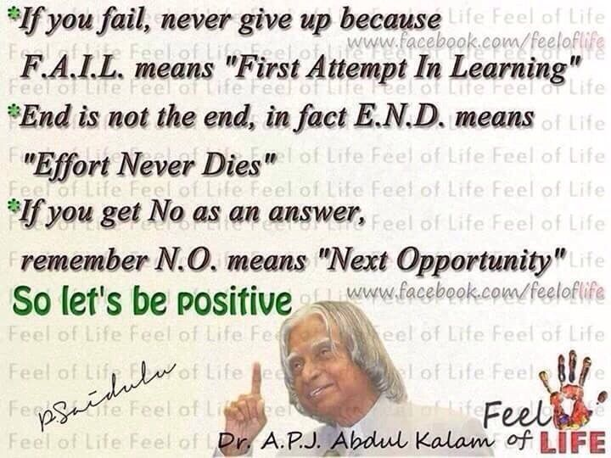
----------------------------------------------------------------------------------------------
Forthcoming Events:
- National Seminar on “Sustainable Solutions to Water, Wastewater and Solid-Waste”, Department of Environmental Sciences, A. N. College, Patna, Bihar- May 08-09, 2015.
- Critical Skills for Implementing Sustainability in the Asia/Pacific Region, Mapletree Business City, Multi Purpose Hall, Level 2; 10 Pasir Panjang Road, Singapore 117438, June -2015.
- Workshop on “Instrumental Techniques in Chemical Research” – Arts, Science and Commerce College, Rahata, Ahmednagar District, Maharashtra; July 09 – 11, 2015.
- Workshop on “Instrumental Methods of Analysis” – Chegudu Vidyalayam, Jaggayyapeta, Andhra Pradesh – August 07-08, 2015.
- NCCT – 2015, Lucknow University, October 08-10, 2015.
- Seminar on “Research Trends in Reaction Kinetics” - Dharbanga, Bihar – October 15-16, 2015.
- Seminar on “Science and Society”, Gayatri Vidya Parishad, Visakhapatnam, November 06, 2015.
- 9th International Conference on Multi-functional Materials and Application”, Suzhou University of Science and Technology, Jiangsu, China, November 26-28, 2015.
- National Chemistry Day - December 10, 2015
-----------------------------------------------------------------------------------

Chemistry associated with the Human Brain Metabolism
The brain consumes up to twenty percent of the energy used by the human body, more than any other organ. Brain metabolism normally relies upon blood glucose as an energy source, but during times of low glucose (such as fasting, exercise, or limited carbohydrate intake), the brain will use ketone bodies for fuel with a smaller need for glucose. The brain can also utilize lactate during exercise. Long-chain fatty acids cannot cross the blood–brain barrier, but the liver can break these down to produce ketones. However the medium-chain fatty acids octanoic and heptanoic acids can cross the barrier and be used by the brain. The brain stores glucose in the form of glycogen, albeit in significantly smaller amounts than that found in the liver or skeletal muscle.
Although the human brain represents only 2% of the body weight, it receives 15% of the cardiac output, 20% of total body oxygen consumption, and 25% of total body glucose utilization. The need to limit body weight has led to selection for a reduction of brain size in some species, such as bats, who need to be able to fly. The brain mostly uses glucose for energy, and deprivation of glucose, as can happen in hypoglycemia, can result in loss of consciousness. The energy consumption of the brain does not vary greatly over time, but active regions of the cortex consume somewhat more energy than inactive regions: this fact forms the basis for the functional brain imaging methods PET and fMRI.^{[36]} These are nuclear medicine imaging techniques which produce a three-dimensional image of metabolic activity.
Different parts of the cerebral cortex are involved in different cognitive and behavioral functions. Researchers who study the functions of the cortex divide it into three functional categories of regions. One consists of the primary sensory areas, which receive signals from the sensory nerves and tracts by way of relay nuclei in the thalamus. Primary sensory areas include the visual area of the occipital lobe, the auditory area in parts of the temporal lobe and insular cortex, and the somatosensory cortex in the parietal lobe. A second category is the primary motor cortex, which sends axons down to motor neurons in the brainstem and spinal cord. This area occupies the rear portion of the frontal lobe, directly in front of the somatosensory area. The third category consists of the remaining parts of the cortex, which are called the association areas. These areas receive input from the sensory areas and lower parts of the brain and are involved in the complex processes of perception, thought, and decision-making.
Understanding the mind–body problem – the relationship between the brain and the mind – is a significant challenge both philosophically and scientifically. It is very difficult to imagine how mental activities such as thoughts and emotions could be implemented by physical structures such as neurons and synapses, or by any other type of physical mechanism. A large body of empirical evidence for a close relationship between brain activity and mental activity has led most neuroscientists and contemporary philosophers to be materialists, believing that mental phenomena are ultimately the result of, or reducible to, physical phenomena. Each hemisphere of the brain interacts primarily with one half of the body, but for reasons that are unclear, the connections are crossed: the left side of the brain interacts with the right side of the body, and vice versa.
The study of how language is represented, processed, and acquired by the brain is neurolinguistics, which is a large multidisciplinary field drawing from cognitive neuroscience, cognitive linguistics, and psycholinguistics. This field originated from the 19th-century discovery that damage to different parts of the brain appeared to cause different symptoms: physicians noticed that individuals with damage to a portion of the left inferior frontal gyrus now known as Broca's area had difficulty in producing language (aphasia of speech), whereas those with damage to a region in the left superior temporal gyrus, now known as Wernicke's area, had difficulty in understanding it. More recently, research on language has increasingly used more modern methods including electrophysiology and functional neuroimaging, to examine how language processing occurs. In the study of natural language, a dedicated network of language development has been identified as crucially involving Broca's area.
References:
  - Parent, A; Carpenter MB (1995). "Ch. 1". Carpenter's Human Neuroanatomy. Williams & Wilkins. ISBN 978-0-683-06752-1.
  - Cosgrove, KP; Mazure CM; Staley JK (2007). "Evolving knowledge of sex differences in brain structure, function, and chemistry". Biol Psychiat 62 (8): 847–55. doi:10.1016/j.biopsych.2007.03.001. PMC 2711771. PMID 17544382.
  - Gur RC, Turetsky BI, Matsui M, Yan M, Bilker W, Hughett P, Gur RE (1999). "Sex differences in brain gray and white matter in healthy young adults: correlations with cognitive performance". The Journal of Neuroscience 19 (10): 4065–72. PMID 10234034.
  - Azevedo, F.A.C., Carvalho, L.R.B., Grinberg, L.T., Farfel, J.M., Ferretti, R.E.L., Leite, R.E.P., Filho, W.J., Lent, R., Herculano-Houzel, S. (2009). "Equal numbers of neuronal and nonneuronal cells make the human brain an isometrically scaled-up primate brain.". Journal of Comparative Neurology 513 (5): 532–541. doi:10.1002/cne.21974. PMID 19226510.
  - Kandel, ER; Schwartz JH; Jessel TM (2000). Principles of Neural Science. McGraw-Hill Professional. p. 324. ISBN 978-0-8385-7701-1.
  - Jones R (2012). "Neurogenetics: What makes a human brain?". Nature Reviews Neuroscience 13 (10): 655. doi:10.1038/nrn3355. PMID 22992645.
  - http://braininfo.rprc.wahington.edu/centraldirectory
  - Swaminathan, Nikhil (29 April 2008). "Why Does the Brain Need So Much Power?". Scientific American. Scientific American, a Division of Nature America, Inc. Retrieved 19 November 2010.
  - Quistorff, Bjørn; Secher, Niels; Van Lieshout, Johanne (July 24, 2008). "Lactate fuels the human brain during exercise". The FASEB Journal 22 (10): 3443. doi:10.1096/fj.08-106104. Retrieved May 9, 2011.
  - "Energy Contribution of Octanoate to Intact Rat Brain Metabolism Measured by 13C Nuclear Magnetic Resonance Spectroscopy". Jneurosci.org. 2003-07-02. Retrieved 2014-03-05.
  - Journal of Cerebral Blood Flow & Metabolism (2012-10-17). "Journal of Cerebral Blood Flow & Metabolism - Abstract of article: Heptanoate as a neural fuel: energetic and neurotransmitter precursors in normal and glucose transporter I-deficient (G1D) brain". Nature.com. Retrieved 2014-03-05.
  - MedBio.info > Integration of Metabolism Professor em. Robert S. Horn, Oslo, Norway. Retrieved on May 1, 2010. [1]
  - Obel, LF; Müller, MS; Walls, AB; Sickmann, HM; Bak, LK; Waagepetersen, HS; Schousboe, A (2012). "Brain glycogen-new perspectives on its metabolic function and regulation at the subcellular level.". Frontiers in neuroenergetics 4: 3. doi:10.3389/fnene.2012.00003. PMC 3291878. PMID 22403540.
  - Clark, DD; Sokoloff L (1999). Siegel GJ, Agranoff BW, Albers RW, Fisher SK, Uhler MD, ed. Basic Neurochemistry: Molecular, Cellular and Medical Aspects. Philadelphia: Lippincott. pp. 637–670. ISBN 978-0-397-51820-3.
  - Safi, K; Seid, MA; Dechmann, DK (2005). "Bigger is not always better: when brains get smaller". Biol Lett 1 (3): 283–286. doi:10.1098/rsbl.2005.0333. PMC 1617168. PMID 17148188.
  - Raichle, M; Gusnard, DA (2002). "Appraising the brain's energy budget". Proc. Natl. Acad. Sci. U.S.A. 99 (16): 10237–10239. doi:10.1073/pnas.172399499. PMC 124895. PMID 12149485.
-----------------------------------------------------------------------------------------------------------------------------------

Views – Science Education

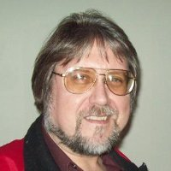Myron Coolbaugh
Assistant Professor of Chemistry at Johnson C. Smith University
Teaching is a craft, which means the experience of the instructor is ultimately the controlling factor. Of course the scientific method can be applied to the craft of science teaching and there is a growing literature on evidence based best practices. Even incremental adoption of some of these practices can have notable effects. For example, Students here are quite enthusiastic about having access to "recordings" of lectures, e.g. lecture presentations with recorded voice over recorded during the class. This goes some way to solve the "lagger" problem by allowing those students to go back and go through difficult parts of the lecture.
------------------------------------------------------------------------------------------------------------------
Editorial Board
Dr. M. R. R. Prasad, Editor Dr. K. Sudhakar Babu
Dr. Altaf Pandit Dr. P.V.S. Machiraju
Dr. D. C. Deka Dr.(Mrs.) Helen Kavitha
Dr. S. P. Singh

